**Problem 1**

1. (a) and (b)

import java.util.Scanner;

import java.lang.Math;

public class test {

static Scanner input = new Scanner(System.in);

public static void main(String args[]){

test q=new test();

q.mid();

q.trap();

}

void mid(){

double y,a,b,d,sum,m;

int n;

sum=0;

Scanner s=new Scanner(System.in);

System.out.println("y=(x*x)+1");

System.out.println("Enter the value of a :");

a=s.nextDouble();

System.out.println("Enter the value of b :");

b=s.nextDouble();

System.out.println("Enter the value of n :");

n=s.nextInt();

d=(b-a)/n;

for(int i=1;i<=n;i++){

m=a+(((2*i)-1)*d)/2;

y=(m*m)+1;

sum=sum+(y*d);

}

System.out.println("Area covered by the given curve = "+sum);

}

void trap(){

double y,a,b,d,sum,m;

int n;

sum=0;

Scanner s=new Scanner(System.in);

System.out.println("y=(x*x)+1");

System.out.println("Enter the value of a :");

a=s.nextDouble();

System.out.println("Enter the value of b :");

b=s.nextDouble();

System.out.println("Enter the value of n :");

n=s.nextInt();

d=(b-a)/n;

for(int i=0;i<=n;i++){

m=((a+(i-1)*d)+(a+(i+1)*d))/2;

y=(m*m)+1;

sum=sum+(y*d);

}

System.out.println("Area covered by the given curve = "+sum);

}

}

1. (a) and (b)

public class test {

static Scanner input = new Scanner(System.in);

public static void main(String args[]){

test q=new test();

q.mid();

q.trap();

}

void mid(){

double y,a=0.0001,b=1,d,sum,m;

int n;

sum=0;

Scanner s=new Scanner(System.in);

System.out.println("y=(x*x)+1");

System.out.println("Enter the value of n :");

n=s.nextInt();

d=(b-a)/n;

for(int i=1;i<=n;i++){

m=a+(((2*i)-1)*d)/2;

double e=Math.E;

double z=Math.pow(m,2);

double v=Math.pow(e,-z);

double w=Math.sin(Math.toRadians(1/m));

y=v*w;

sum=sum+(y*d);

}

System.out.println("Area covered by the given curve = "+sum);

}

void trap(){

double y,a=0.0001,b=1,d,sum,m;

int n;

sum=0;

Scanner s=new Scanner(System.in);

System.out.println("y=(x*x)+1");

System.out.println("Enter the value of n :");

n=s.nextInt();

d=(b-a)/n;

for(int i=0;i<=n;i++){

m=((a+(i-1)*d)+(a+(i+1)*d))/2;

double e=Math.E;

double z=Math.pow(m,2);

double v=Math.pow(e,-z);

double w=Math.sin(Math.toRadians(1/m));

y=v*w;

sum=sum+(y*d);

}

System.out.println("Area covered by the given curve = "+sum);

}

}

***GRAPH***

**Mid (blue)**

10 - 0.06668910543158103

30 - 0.08016584147509677

100 - 0.0664316511440565

300 - 0.06976871004422278

1000 - 0.06943206762879772

3000 - 0.07113353600642496

10000 - 0.07127312451801959

**Trap (red)**

10 - -0.05497122281736331

30 - 0.028747550361688846

100 - 0.06427816328170294

300 - 0.06624508736434243

1000 - 0.0703690638946534

3000 - 0.07056779367951538

10000 - 0.07088254790131691

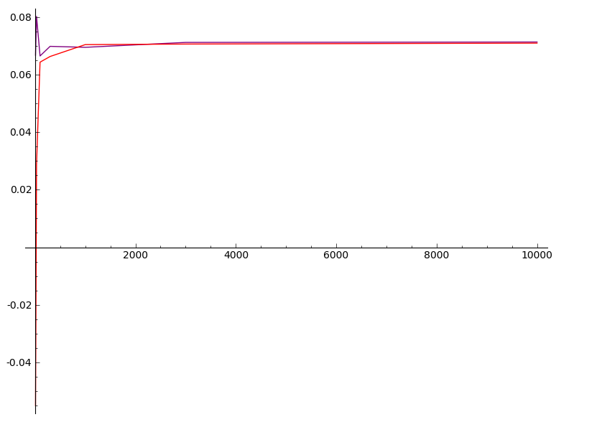

**Problem 2**

Part 4

void trap(){

double y,a,b,d,sum,m,x1,x2,fx1,fx2,fm;

int n;

sum=0;

Scanner s=new Scanner(System.in);

System.out.println("y=(x*x)+1");

System.out.println("Enter the value of a :");

a=s.nextDouble();

System.out.println("Enter the value of b :");

b=s.nextDouble();

System.out.println("Enter the value of n :");

n=s.nextInt();

d=(b-a)/n;

for(int i=0;i<=n;i++){

x1=(a+(i-1)*d);

x2=(a+(i+1)*d);

m=((a+(i-1)*d)+(a+(i+1)*d))/2;

fx1=(x1*x1)+1;

fx2=(x2*x2)+1;

fm=(m*m)+1;

y=(d*(fx1+(4*fm)+fx2))/6;

sum=sum+y;

}

System.out.println("Area covered by the given curve = "+sum);

}